 | Phonics/  Spelling | English | Break | Maths fluency | Maths | Lunch | Topic session 1 | Break | Topic session 2
Monday | Drop the ‘y’ and add ‘ied’ to make past tense e.g cried, tried | https://classroom.thenational.academy/lessons/to-listen-and-respond-to-a-story-64rpar |  | Dividing by 2,5,10  20 ÷ 2  18 ÷ 2  35 ÷ 5  80 ÷ 10 | https://classroom.thenational.academy/lessons/make-10-c4t6ar |  | SCIENCE  https://classroom.thenational.academy/lessons/how-does-the-earth-orbit-and-rotate-c4tpcd |  | SCIENCE  https://classroom.thenational.academy/lessons/what-are-constellations-6rukac
Tuesday | Drop the ‘y’ and add ‘ied’ to make past tense e.g cried, tried | https://classroom.thenational.academy/lessons/to-tell-a-story-from-memory-c4wkat |  | Dividing by 2,5,10  20 ÷ 2  18 ÷ 2  35 ÷ 5  80 ÷ 10 | https://classroom.thenational.academy/lessons/adding-two-digit-numbers-and-ones-with-regrouping-6cv38c |  | ART  https://www.youtube.com/watch?v=v368l7nAltE  Creating a landscape |  | ART  Continue making a landscape
Wednesday | Drop the ‘y’ and add ‘ied’ to make past tense e.g cried, tried | https://classroom.thenational.academy/lessons/to-explore-character-6rtp6t |  | Dividing by 2,5,10  20 ÷ 2  18 ÷ 2  35 ÷ 5  80 ÷ 10 | https://classroom.thenational.academy/lessons/adding-two-digit-numbers-with-regrouping-6cup4r |  | MINDFULNESS  See mindfulness activity on the next page |  | P.E  https://www.youtube.com/c/TheBodyCoachTV/videos  Participate in a Joe Wicks session
Thursday | Drop the ‘y’ and add ‘ied’ to make past tense e.g cried, tried | https://classroom.thenational.academy/lessons/to-show-not-tell-how-a-character-is-feeling-6mr66d |  | Dividing by 2,5,10  20 ÷ 2  18 ÷ 2  35 ÷ 5 | https://classroom.thenational.academy/lessons/adding-two-digit-numbers-involving-regrouping-60vked |  | PSHE  https://classroom.thenational.academy/lessons/one-big-family-74vp2e |  | PSHE  https://classroom.thenational.academy/lessons/same-or-different-cthkac
Friday | Drop the ‘y’ and add ‘ied’ to make past tense e.g cried, tried | https://classroom.thenational.academy/lessons/to-make-inferences-based-on-what-is-said-and-done-71h38d |  | Dividing by 2,5,10  20 ÷ 2  18 ÷ 2  35 ÷ 5  80 ÷ 10 | https://classroom.thenational.academy/lessons/using-the-make-10-strategy-to-subtract-ones-60r3ct |  | HISTORY  https://classroom.thenational.academy/lessons/how-have-the-ways-in-which-we-communicate-changed-over-time-part-1-6grp4d |  | HISTORY  https://classroom.thenational.academy/lessons/how-have-the-ways-in-which-we-communicate-changed-over-time-part-2-6cr64c
Mindfulness activity
Create a gratitude diary.
This will be used each day. The children will write down or draw what they are grateful for. It is important to try not to focus on ‘things’. More feelings, people etc. Here is a link where Dr Rangan talks about the benefits:
https://www.scouts.org.uk/news/2020/april/one-good-thing-how-keeping-a-gratitude-diary-builds-resilience/
The diary can be a piece of paper that the children record their thoughts on; it can be a booklet they make from paper; it could be a bought book that they decorate.
If a child doesn’t have anything to make a diary or forgets to record their gratitude list- they could play a game with their family at the dinner table- what are you grateful for and they just say it out loud. E.g. I am grateful that I get to sit down with my family at the end of the day and eat tea and laugh together.
I am grateful for waking up before my alarm and being able to enjoy a cup of tea in peace before a busy day at work.
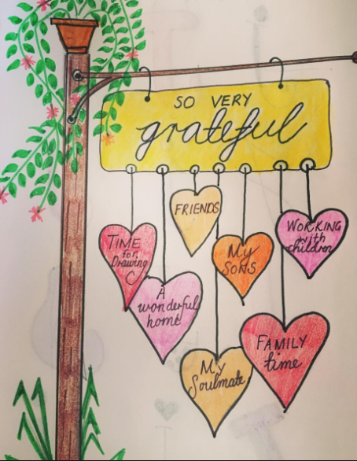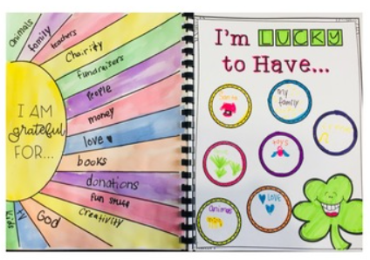
Phonics Play
Log onto Phonics play https://www.phonicsplay.co.uk/
Username: jan21
Password: home
Play phase 5 tricky word games

Oxford owl
Please spend time reading with your child. If you are running out of books at home oxford owl has ebooks for your children to read. https://home.oxfordowl.co.uk/reading/free-ebooks/

#21minutechallenge
Rossendale School Sports Partnership have put together a number of resources to help our children and families stay active during this lockdown. To support this, they have launched the 21 minute challenge. The aim is to take part in at least 21 minutes of continuous exercise every day, whether it is going out for a walk, taking part in a home learning task from school, playing out with siblings or completing a Joe Wicks workout. We are encouraging our school and home learners (and their families) to take part and log their daily activities. Please follow the home learning links on our school website for the activity log. It would be amazing to see as many of our families getting out and being active. https://www.thorn.lancs.sch.uk/pe-resources-rossendale-school-sports-partnership-/

Bird watching
RSPB are doing a bird watching activity from the 29th to 31st January. Here is a link so you can take part if you like.
https://www.rspb.org.uk/get-involved/activities/birdwatch/everything-you-need-to-know-about-big-garden-birdwatch/

National Marine Aquarium
Deep Science
Every Friday during the lockdown, you will be able to tune in to two special shows on our Youtube Channel here: Click here to visit our YouTube channel
FRIDAYS AT 1:00PM – 1:20PM [KS1&2]
The first, ‘Deep Science’ (1:00pm – 1:20pm) will see our Aquarium teachers meet some of our amazing animals as well as stopping in at our Aqua Lab to explore the science behind the animated ocean exploration tv series ‘The Deep’ (CBBC @12pm on weekdays during lockdown). Expect fascinating facts and real time experiments, as well as ideas to follow up with at home (curriculum linked of course!)
Key themes for each week are as follows:
15th Jan – Underwater Volcanoes
22nd Jan – Creature Classification
29th Jan – Nautical Navigation
5th Feb – Ocean Mysteries
12th Feb – Megafauna
19th Feb – Life Cycles
26th Feb – Looking after the Ocean
https://www.youtube.com/user/NMAPlymouth/videos

