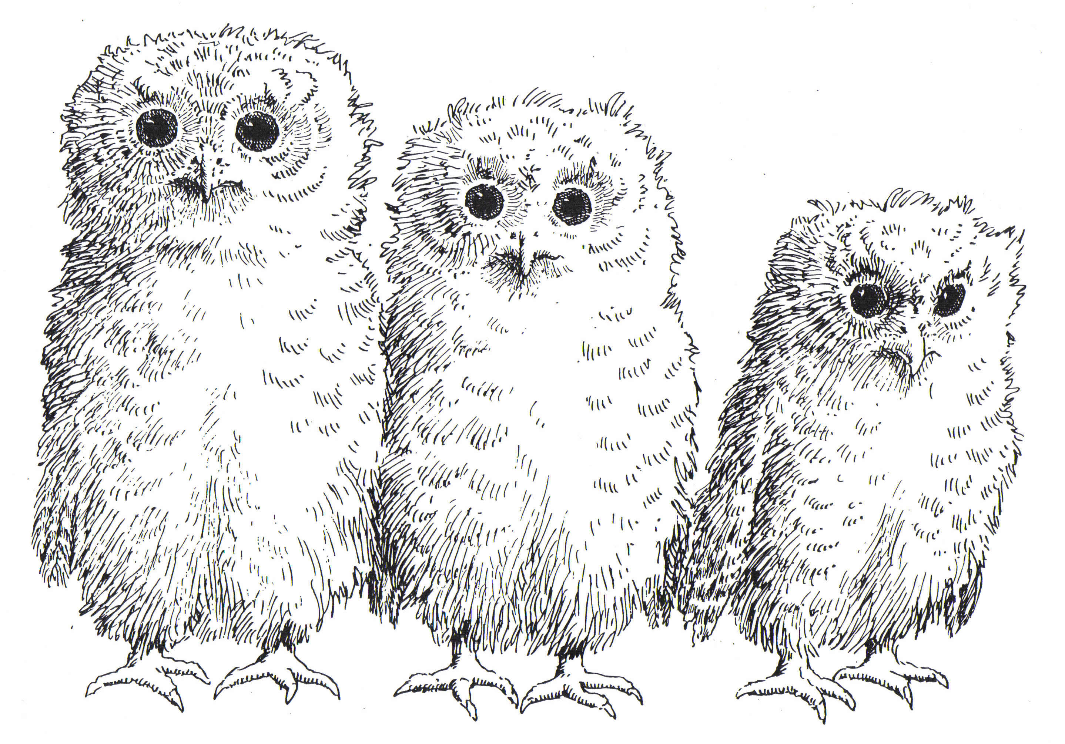

I feel
I feel

I feel
sad
scared
lonely
confused
worried

