Q1.

DISASTER
STRIKES
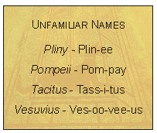  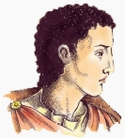  Pliny | In the first century AD, in the period of the Roman Empire, Vesuvius had been dormant for hundreds of years. The mountain was green as farmers grew fig and olive trees on the slopes of the volcano and the local people had become used to the tremors of earthquakes from time to time.  In the summer of AD 79 there had been more rumbling than usual but in the town of Pompeii and in the whole area surrounding the volcano, most people went about their daily business.  One of them, a boy called Pliny, was 17 at the time. When the volcano erupted, he watched from a nearby town as the earth shook and a black cloud descended over the area. Pliny’s uncle, the commander of a nearby naval port, also saw the unusual cloud forming above Mount Vesuvius. He was not content to stand by and watch. He wanted to get a closer look and set off to investigate with a scribe to whom he could dictate his observations.
As he was leaving, he received a message from his friend Rectina asking if he would help her. So he set out with several ships to observe the volcano and try to rescue the people. Years later, Tacitus, a historian, was collecting information about the event. Pliny wrote to him giving a vivid account of what he had seen and heard. Not only was he an eye-witness to the disaster, but Pliny also heard the stories told by survivors, some of whom had been rescued by his uncle. The following is an extract from Pliny’s letter to Tacitus:
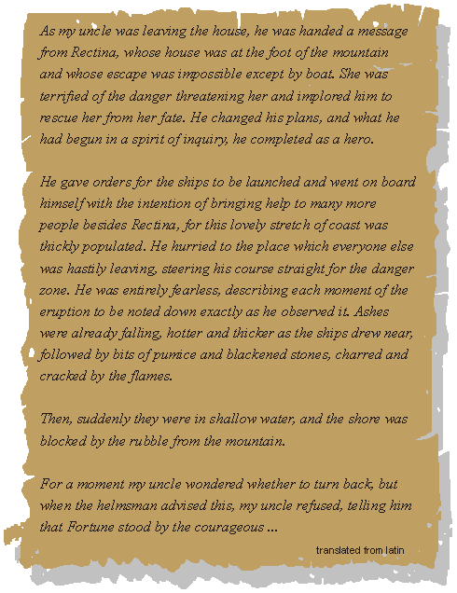
Later in his letter to Tacitus, Pliny records that his uncle died in the eruption.
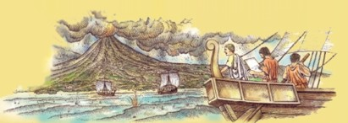
Q2.

1. The following are the people who were mentioned in Disaster Strikes.
Draw lines to match the names with the correct descriptions.
One has been done for you.
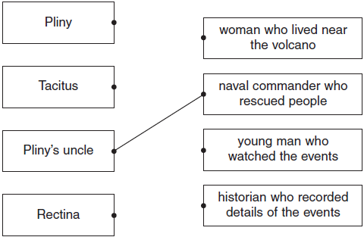
1 mark
2. Look again at Pliny’s account of his uncle’s journey.
The events are described below, but they are in the wrong order.
Number them 1 - 5 to show the order in which they appear in the text.
The first one has been done for you.

ordered launching of ships
received letter from Rectina
came close to land
refused to listen to advice
journeyed into danger zone
2 marks
3. Look at the information about Mount Vesuvius in AD 79. (page 1)
How do you know that life was peaceful in the area?
___________________________________________________________________
___________________________________________________________________
1 mark
4. Find and copy two phrases, one from page 1 and one from page 2, to show that Pliny’s uncle wanted to study the volcano.
(a) Evidence from page 1:
______________________________________________________________
1 mark
(b) Evidence from page 2:
______________________________________________________________
1 mark
5. What dangers made the helmsman want to turn back?
Give two examples:
1. _________________________________________________________________
2. _________________________________________________________________
2 marks
6. Pliny’s uncle received a written message from Rectina stating her problem and asking for his help.
What do you think Rectina wrote?
Using the information you have read, write Rectina’s message below.
3 marks
7. Some people think that Pliny’s uncle was a brave but foolish leader.
What do you think?

brave |  | foolish |  | brave and foolish
Explain your answer using parts of the information to help you.
3 marks

