Q1.

Dear Norman
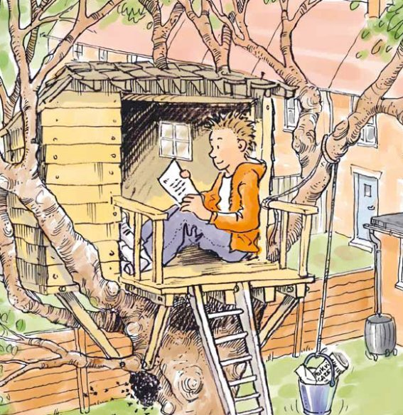

Monday, 16th of June
Dear Norman,
Thank you so much for your letter which arrived just before lunch.
It came as quite a surprise when you left with all of your possessions this morning. We did not understand why you left through the back door. Now we know that it was because you have gone to live in your tree house in the back garden.
I am sure that your decision to leave our family is a serious one. Therefore I would like to wish you all the best for the exciting new life you are starting on your own. Please do keep in touch from up there.
Love
Dad

Monday evening
Dear Norman,
You are very sweet to take the time to write. Thank you for explaining our mistakes in such detail. Your father and I will find your advice very useful.
I hope that life in your tree house is calming down since you moved in earlier today. I could see how difficult it was to carry all your things up that long, steep ladder by yourself. How did you manage to get that big TV set up there? It certainly was clever.
No doubt you took plenty of food with you up into your tree house. I have this extra cheese sandwich and a chocolate bar left over. I am sending them up your message rope with this letter in the hope that you can use them in some way. By the way, did you see those sweet busy bees below your tree house? I suppose they could be hornets or wasps, but don’t worry, they look more like jolly bumble bees to me.
If you think of any other mistakes your father and I made don’t hesitate to get in touch.
Meanwhile, lots of love from
Mum
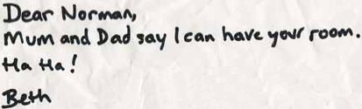
17th of June, 2008
Dear Norman,
I understand from your parents that I should not expect to see you in school for some time due to changes in your personal life. Please take as much time as you feel you need.
Perhaps school no longer seems important now that you live in a tree house behind your family’s home. That makes sense. Geography, Music, History: which of the lessons you missed this morning would be useful in a tree house? None, probably.
What you need are different skills, skills useful for life in the wild: How to keep a small, safe fire burning for light and warmth. How to tell good berries, nuts and mushrooms from deadly ones. Which animals you will compete with for territory. Unfortunately, we don’t study any of these at Parkville School. You will have to do most of your learning on your own, Norman.
Should you decide to continue any of your studies with us, please send me a note. I cannot send you all of the fun and friendship from our class here at Parkville School, but can certainly send you the homework!
Your sincerely,

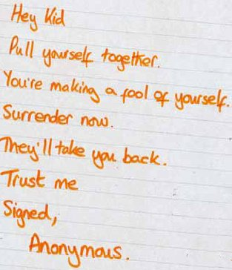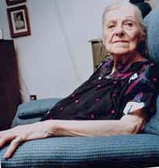

June 18th, 2008
Dear Norman,
I hope you are well and not spending too much time worrying about your lonely old grandmother. I’m fine most of the time. I do have bad days when none of my grandchildren have visited or telephoned, but try to remain cheerful.
Your mother says you have been acting strange lately. Stop it; that’s not polite.
Next time you speak to my son (your father), please tell him from me (his mother, your grandmother) that it’s high time he wrote a letter to his mother (me).
I’m so glad you liked the sweater I sent for your birthday.
I can’t wait to see all of you next weekend. You are what keeps me happy!
Love
Grandma

Hey Norm,  What’s this about you living in your tree house now? Totally cool! Does this mean you can eat whatever you want? Stop washing? Stop brushing your teeth? Are you going to wear the same clothes every day for a year? Just think: you can spend the whole night playing with your Gameboy! You can stay on strike for months! This is so cool. I wish I had thought of it.  Alfred  P.S. Can I have your bike? | 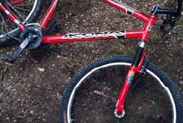

Wednesday, 18th June
Dear Norman,
Thank you for your letter explaining why you do not want any pocket money this week. It made your mother and me wonder how much we would save if you continue this practice for the remainder of your childhood.
10 years × 52 weeks per year × £2 per week pocket money = £1,040 total savings.
(You might want to check our maths.)
Isn’t it amazing the way it adds up?
Love
Dad

18.06.2008
Dear Norman,
Congratulations! Your article “Peace Now” has won First Prize in the Parkville Gazette’s Solving the World’s Problems Contest! The judges were especially impressed by the section “Peace begins in Your Own Back Garden”.
As you know, the First Prize in the Solving the World’s Problems Contest is a trip to Washington D.C. where you will visit the White House and actually discuss your article with the President of the United States. You will be able to take one member of your family with you on this once-in-a-lifetime trip.
Please ask your parent or guardian to contact me as soon as possible to make arrangements for the trip.
And congratulations once again on your wise article!
Best wishes,
The Editor
The Parkville Gazette
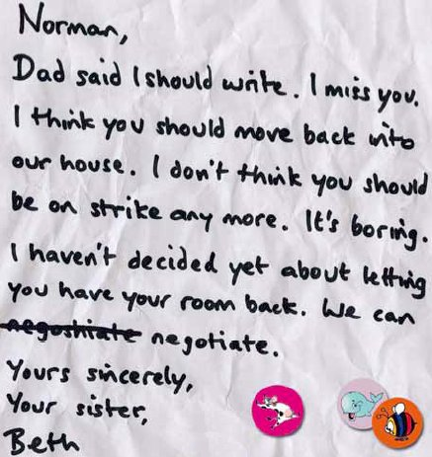

Thursday a.m.
Dear Norman,
Thank you for your letter. I understand your feelings. It will be okay just to move back into the house. Don’t forget to wipe your feet.
Love,
Mum
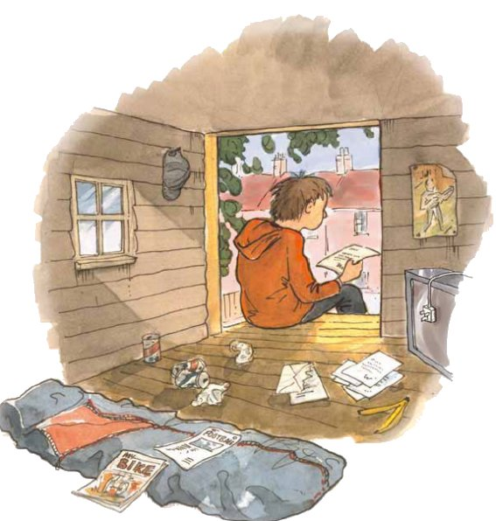
Q2.

1. Circle the correct option to complete the sentences below.
(a) On
morning, Norman left home.
1 mark
(b) He went to live in a tree house in

1 mark
(c) He had left home because
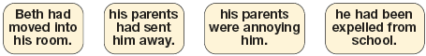
1 mark
(d) Over the next few days, he received letters from people that he knew, starting with letters from

1 mark
(e) A letter came from his friend Alfred, asking him for his
1 mark
(f) He even got a letter from the local newspaper telling him that

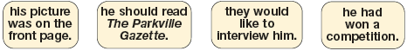
1 mark
(g) Altogether, he stayed in his tree house for

1 mark
Here are some of the people who wrote to Norman.
Use these names to answer next couple of questions.
2. Who admired Norman most for what he had done?

Tick one.
Dad
Mum
Beth
Mrs Bouquet
Grandma
Alfred
Find and copy one phrase that shows this.
___________________________________________________________________
___________________________________________________________________
1 mark
3. Whose letter do you think was most likely to annoy Norman?

Tick one.
Dad
Mum
Beth
Mrs Bouquet
Grandma
Alfred
Explain why, referring to the letter in your answer.
___________________________________________________________________
___________________________________________________________________
___________________________________________________________________
2 marks
4. Look at the letter beginning ‘Hey kid’.
Find and copy one word meaning give up.
___________________________________
1 mark
5. What do you think Norman wrote in reply to Alfred’s letter on page 5?
2 marks
6. Beth’s letters show a change in her attitude to Norman.
a) Find and copy one word or phrase from both of Beth’s letters that best show her change in attitude.
___________________________ ________________________
(first letter, page 3) (second letter, page 7)
1 mark
b) Why do you think her attitude towards Norman changed?
______________________________________________________________
______________________________________________________________
______________________________________________________________
2 marks
7. In his second letter (page 5), Norman’s father showed Norman how much money he was missing out on.
Why did he do that?
___________________________________________________________________
___________________________________________________________________
___________________________________________________________________
2 marks
8. How do we know that Norman actually answered the letters he received?
___________________________________________________________________
___________________________________________________________________
___________________________________________________________________
1 mark
9. The idea of a child living in a tree is quite humorous.
Explain what else is funny about Norman’s situation.
___________________________________________________________________
___________________________________________________________________
___________________________________________________________________
2 marks
10. Why do you think Norman finally came down from the tree?
Explain fully, using the text in your answer.
3 marks

up to 3 marks

