Monday 22nd February 2021 Make simple inferences using pictorial clues.
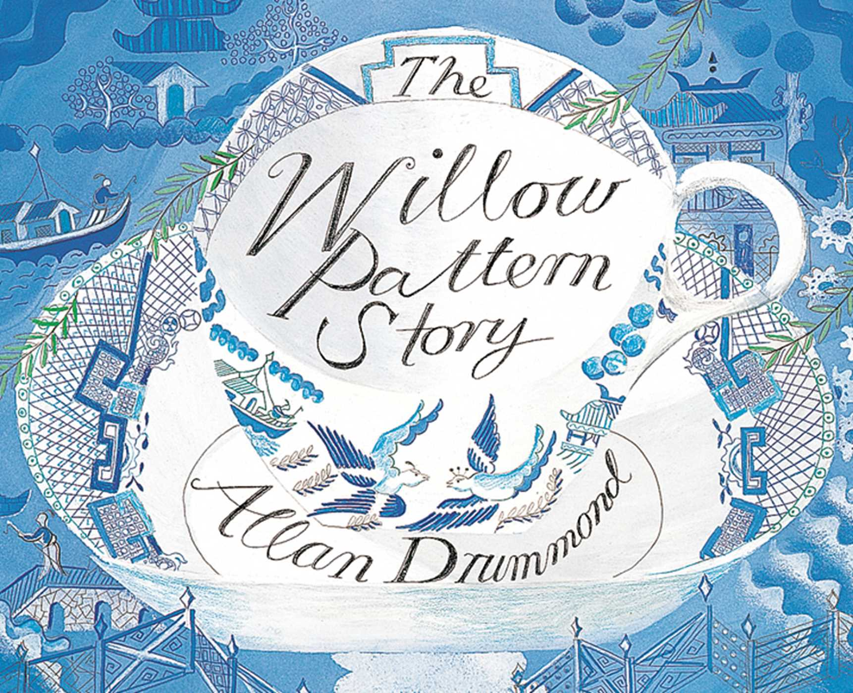 | Observe- What can you see in the picture? Use precise nouns and describe in detail what you can see.
Wonder- What questions do you have? What do you wonder? | Infer- What can you work out? What makes you think this? Do you know where it might be set? Fiction or non- fiction- why?

