Week 5 Pebble in my pocket guided reading questions –
1. Name one thing that drifts down onto the seabed.
2. What type of creature hunts amongst rotting wood?
3. How long did it take for the earth to rise up by one metre?
4. The dinosaur’s legs are as big as _______?
5. When is the pebble released?

6. Find the phrases which tell us that the process of the earth rising took a long time.

7. Why do the small mammals crouch under the rock?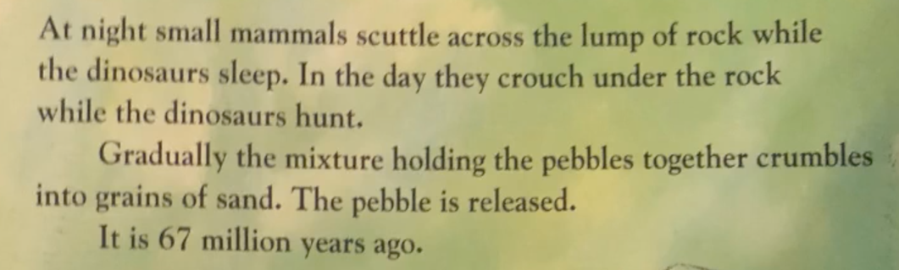
8. Which word tells us how the small mammals are moving?

True or False –
Change any false answers into true statements.
1. The seabed contains the tiny bodies of dead sea creatures.
2. When the surface of the earth begins to rise, the pebble can still be seen.
3. The fossils of dead sea creatures lie at the bottom of the mountain.
4. The dry wind is blown from deserts that are far away.
5. All dinosaurs eat meat.

