

ENGAGE – INSPIRE - ACHIEVE

The Christian family of St Paul’s… moving forward together.
A caring, exciting and happy school where everyone succeeds!
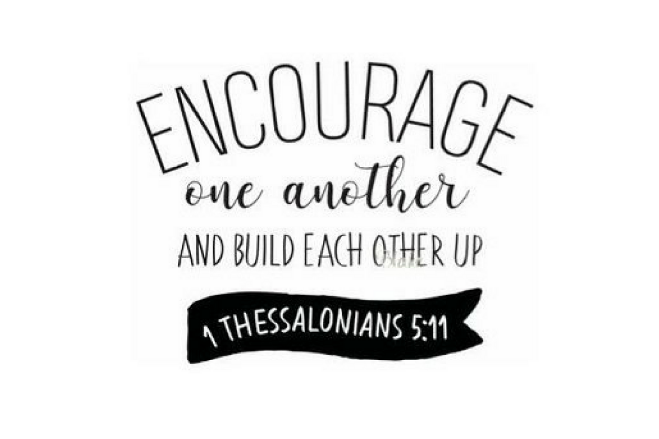
Spiritual, Moral, Social and Cultural Development Policy
September 2019
POLICY STATEMENT
This document is a statement of aims and strategies for the teaching and learning of Spiritual, Moral, Social and Cultural (SMSC) Development at St Paul’s Church of England Primary School, Rawtenstall.

LINKS TO OTHER POLICIES
- Worship Policy
- RE Policy

AIMS
St Paul’s mission statement, ‘The Christian Family of St Paul’s… A caring, exciting and happy school where everyone succeeds!’ and the school values underpin all of the work that we do at St Paul’s, not only through all the subjects of the curriculum but also through the ethos of the school and through the development of positive attitudes to learning and behaviour.
Spiritual, Moral, Social and Cultural Development is cross curricular and it is an expectation that all staff, in all subjects, can, and should make a contribution to the Spiritual, Moral, Social and Cultural Development of pupils through the curriculum and through the use of appropriate teaching and learning strategies e.g. discussion, reflection, pupil participation, circle time and also through their own conduct.
The importance of relationships between all school staff, parents and governors is vital. These relationships will be characterised by mutual respect, by positive attitudes, by the willingness to listen and be listened to and by the valuing of all pupils.

Spiritual Development
This relates to the quest for individual identity and the search for meaning and purpose in our existence. It leads towards the understanding of self and others. It has to do with feelings, emotions, attitudes and beliefs. It is not linked solely to a particular doctrine or faith and spiritual development is therefore accessible to everyone.
Children are given opportunities to reflect upon the meaning of spiritual experiences. Examples of experiences commonly regarded as spiritual include:
- Curiosity and questions
- Awe and wonder
- Connection and belonging
- Heightened self-awareness
- Prayer and worship
- Deep feelings of what is felt to be ultimately important
- A sense of security, well-being, worth and purposefulness

Our school supports children’s spiritual development by:
- Giving children the opportunity to explore values and beliefs, including religious beliefs, and the way in which they impact on peoples’ lives
- Giving children the opportunity to understand human feelings and emotions, the way they impact on people and how an understanding of them can be helpful
- Developing a climate or ethos within which all children can grow and flourish, enjoying individual liberty and mutual respect
- Accommodating difference and respecting the integrity of individuals, including tolerance of those with different faiths and beliefs
- Promoting learning opportunities which value children’s questions, encourage deeper questions and give them space for their own thoughts, ideas and concerns

Moral Development
Children are encouraged to understand the need for treating others as they would wish to be treated and respecting the school values. At St. Paul’s School we have our school Golden Rules in which we encourage children to follow:
1) Speaking and behaving respectfully to everyone.
2) Listening and following instructions.
3) Taking care of everything in school.
Our school supports children’s moral development by:
- Providing our Golden Rules as a basis for behaviour which is promoted consistently through all aspects of the school
- Promoting racial, religious and other forms of equality
- Challenging stereotyping
- Giving pupils opportunities across the curriculum to explore and develop moral concepts and values –for example, personal rights and responsibilities, truth, justice, equality of opportunity, right and wrong
- Developing an open and safe learning environment in which pupils can express their views and practise moral decision making
- Rewarding positive behaviour
- Encouraging pupils to take responsibility for their actions, for example, respect for property, care of the environment, and developing codes of behaviour
- Providing models of moral virtue through literature, humanities, sciences, arts and assemblies; reinforcing the school’s values through images, posters, classroom displays, etc. and monitoring in simple ways, the success of what is provided

Social Development
This enables pupils to become conscientious participants in their family, class, school, the local and wider community and make a positive contribution to the lives of others in society. Within this there should be a balance of the positive, satisfying elements of belonging to a group or society along with the demands, obligations and cooperation such membership requires.
Our school develops pupil social development by:
- Identifying key values and principles on which school and community life is based
- Fostering a sense of community, with common, inclusive values
- Promoting racial, religious and other forms of equality
- Encouraging pupils to work co-operatively
- Encouraging pupils to recognise and respect social differences and similarities
- Providing positive experiences to reinforce our values as a school community –for example, through worship, team building activities, especially in Forest School, residential experiences, school productions
- Helping pupils develop personal qualities, which are valued in a civilised society, for example, thoughtfulness, honesty, respect for difference, moral principles, independence, interdependence, self-respect and awareness of others’ needs
- Providing opportunities for engaging in the democratic process and participating in community life
- Providing opportunities for pupils to exercise leadership and responsibility
- Providing positive and effective links with the world of work and the wider community

Cultural Development
At the heart of cultural development, lies the necessity to develop a sense of personal identity, whilst at the same time acquiring awareness, understanding and tolerance regarding the cultural traditions and beliefs of others.
Our school develops cultural development by:
- Encouraging children to think about special events in life and how they are celebrated
- Recognising and nurturing particular gifts and talents; providing opportunities for pupils to participate in literature, drama, music, art, crafts and other cultural events and encouraging pupils to reflect on their significance
- Reinforcing the school’s cultural links through displays, posters, exhibitions, etc.
- Developing partnerships with outside agencies and individuals to extend pupils’ cultural awareness, for example, theatre, museum and gallery visits

OUTDOOR CLASSROOM
- Where possible and appropriate, the outdoor classroom/ Forest School will be used to support children in the development of their spirituality. Our two new Spiritual Gardens will encourage children in their curiosity and questioning and the development of their sense of awe and wonder.
- Providing access to our Forest School and Spiritual Gardens will aim for our children to develop a sense of belonging and security, well-being, worth and purposefulness.

STAFF TRAINING
Through INSET and Staff Meeting opportunities in school, we will ensure that our staff are fully trained to teach through aspects of SMSC.

VISITORS AND THE USE OF SCHOOL PREMISES
If any member of staff wishes to invite a visitor in the school for the teaching of SMSC sessions, they must first discuss this with their Unit Head and the Headteacher. Only after agreement from the Head Teacher can the visitor enter school. Children are NEVER left unsupervised with external visitors, regardless of safeguarding check outcomes.
Upon arriving at the school, all visitors to lead worship will be escorted by the school staff member who invited them.
POLICY REVIEW
The SMSC Policy will be reviewed annually as part of the overall Safeguarding and Child Protection Policy review.
This policy will be ratified by the Governing Body in September 2019
Signed by Mr W Aitkin (Chair of Governors) Date: September 2019
This policy will be reviewed on or before the following date: September 2020



