**Science**

In science, the children will continue work on animals. They will then be linking all of this learning to humans. The children will label and learn body parts. They will also focus on the needs of humans and living healthily.

**ICT**

In this half term the children will be using Purple Mash to gather data.

**PE**

Ball control and skills.

**RE**

We will be looking at Easter.

**PSHCE**

We will be working through our Safety and Danger Topic.

**English**

This half term our literacy units will include traditional tales, non-chronological reports and poetry.

The children will look at the layout of non-chronological reports and will be able to write one of their own. This will be based on Spectacled Bears.

When looking at traditional tales. The children will identify features of traditional tales, settings, and look at alternative endings, character descriptions and story language.

The children will also take part in phonics daily, which will be taught in phase groups.

**Numeracy**

This half term the children will be looking at the following:

* Length and mass/weight
* Addition and subtraction
* Fractions
* Position and direction
* Time

Sycamores Topic Web – spring 2

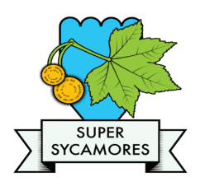

Our Country

**Creative Curriculum**

History

We will be learning about Monarchs and Queen Elizabeth 11. We will be learning about her life and her role.

Geography

We will be looking at Maps with a focus on identifying landmarks. We will also be using a compass.

Art

We will be doing self-portraits.