Q1.
Estimate the answer to this calculation.
23,901 – 5,097
Circle the correct estimate.
6,000 17,000 18,000
19,000 20,000
1 mark
Q2.

This table shows the heights of three mountains.

Mountain | Height in metres
Mount Everest | 8,848
Mount Kilimanjaro | 5,895
Ben Nevis | 1,344
How much higher is Mount Everest than the combined height of the other two mountains?
2 marks
Q3.

Write the four missing digits to make this addition correct.

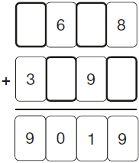
2 marks
Q4.

At the start of June, there were 1,793 toy cars in the shop.
During June,
• 8,728 more toy cars were delivered
• 9,473 toy cars were sold.
How many toy cars were left in the shop at the end of June?
2 marks
Q5.

Nadia is working with whole numbers.
She says,
'If you add a two-digit number to a two digit number you cannot get a four-digit number.
Is she correct? Circle Yes or No. Yes / No
Explain why.
1 mark
Q6.
14,890 festival tickets were sold before the event.
Another 6,752 were sold on the day.
546 people did not arrive at the festival.
How many people were at the festival altogether?
2 marks
Q7.

Liam has two different sizes of rectangle.

He makes this pattern with them.

Not actual size
Calculate the lengths of A and B.
1 mark
1 mark
Q8.

Emily chooses two numbers.

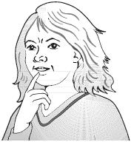
She adds the two numbers together and divides the result by 2
Her answer is 44
One of Emily’s numbers is 12
What is Emily’s other number?

2 marks
Q9.

A drink and a box of popcorn together cost 90p.

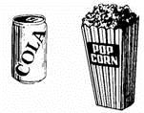
2 drinks and a box of popcorn together costs £1.45

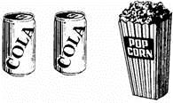
What does a box of popcorn cost?
1 mark
Explain how you got your answer.
1 mark
Q10.

Amir has three parcels.
Parcels A and B together weigh the same as parcel C.
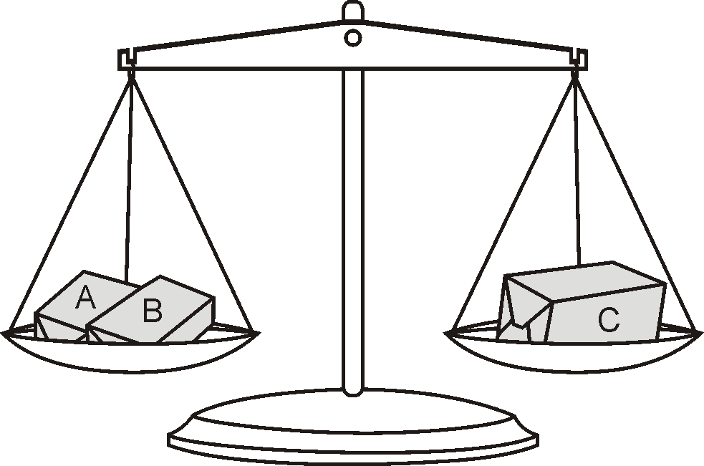
The three parcels weigh 800 grams altogether.
Parcel A weighs 250 g.
How much does parcel B weigh?

2 marks

Mark schemes
Q1.
19,000
[1]
Q2.

Award TWO marks for the correct answer of 1,609
If the answer is incorrect, award ONE mark for evidence of an appropriate method, e.g.
• 5,895 + 1,344 = 7,239
8,848 − 7,239
Answer need not be obtained for the award of ONE mark.
Up to 2m
[2]
Q3.
Award TWO marks for four boxes completed correctly, as shown.
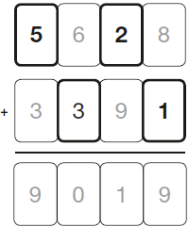
If the answer is incorrect, award ONE mark
for three boxes completed correctly.
Up to 2
[2]
Q4.

Award TWO marks for the correct answer of 1,048
If the answer is incorrect, award ONE mark for evidence of an appropriate method, e.g.
• 1,793 + 8,728 = 10,521
10,521 − 9,473
OR
• 9,473 − 8,728 = 745
1,793 − 745
Answer need not be obtained for the award of ONE mark.
Up to 2m
[2]
Q5.
Explanation which recognises that the largest two-digit number (99) added
to itself only gives a three-digit number (198), eg
• ‘Because if you do 99 + 99 you only get a three-digit number’;
• ‘If you add any 2 two-digit numbers, you will get a three-digit number or a
two-digit number’.
No mark is awarded for circling the ‘Yes’ alone.
Do not accept vague or arbitrary explanations such as
• ‘The numbers aren’t big enough’;
• ‘It doesn’t work’.
If ‘No’ is circled but a correct unambiguous explanation is
given then award the mark.
[1]
Q6.
Award TWO marks for the correct answer of 21,096
If the answer is incorrect, award ONE mark for evidence of an appropriate method, with no more than one arithmetic error e.g.
14,890 + 6,752 = 21,642
21,642– 546 = (no answer or wrong answer)
OR
14,890 – 546 = 14,354 (error)
14,354 + 6,752 = 21,106
[2]
Q7.
(a) 5
1
(b) 15
If the answer is incorrect, award the mark if the answers to (a) and (b) total 20
U1
[2]
Q8.
Award TWO marks for the correct answer of 76
If the answer is incorrect, award ONE mark for evidence of appropriate
method, eg
44 × 2 = 88
88 – 12
Answer need not be obtained for the award of ONE mark.
Up to 2
[2]
Q9.
(a) 35p
Answer to 17a may be embedded in answer to 17b.
In this case, award one mark for correct answer.
1
(b) Explanation which includes reference to any appropriate method even if the
answer is incorrect, eg:
• I took 90 from 145 and took my answer from 90
• If a drink and popcorn costs 90p you add to it however much it takes to make 145, which is 55p so you times 55 by 2 which is 110 and take away 145 and you get 45 (incorrect answer).
OR
a trial and improvement approach, eg:
• I thought they might both cost 45p. I guessed the drink and doubled it to make 90p, then added another 45 but I got 10 less than £1.45. So I tried 55 and it worked so the popcorn is 35
Accept appropriate numerical working elsewhere on page as adequate explanation. If there is no working and no explanation, there is no mark for 17b, even if 17a is correct.
If answer to 17a is correct, accept appropriate non-numerical answer to 17b, (ie no reference to actual amounts of money).
1
[2]
Q10.
Award TWO marks for the correct answer of 150
If the answer is incorrect, award ONE mark for evidence of appropriate
working, eg
800 ÷ 2 = 400
400 – 250 = wrong answer
Working must be carried through to reach an answer for the award of ONE mark.
Up to 2 (U1)
[2]

