Q1.

Write these numbers in the correct places on the diagram.
5 6 7 8

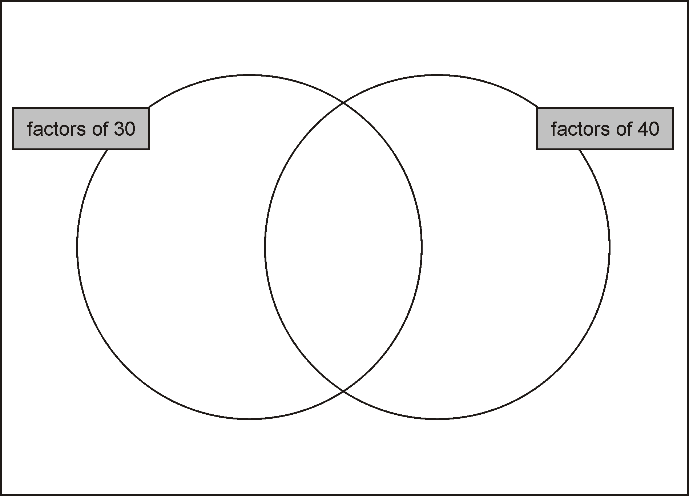
2 marks
Q2.
Tick the numbers that are common factors of both 12 and 18

2
3
6
9
12
2 marks
Q3.

Write three factors of 30 that are not factors of 15
2 marks
Q4.

Here are six digit cards.

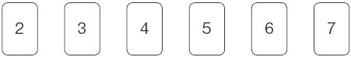
Use all six digit cards to make three multiples of 3

1 mark
Q5.

Write all the common multiples of 3 and 8 that are less than 50
________________________________________________
1 mark
Q6.

Here are five number cards.

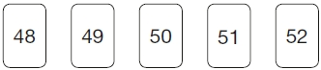
Use each card once to make every statement below correct.

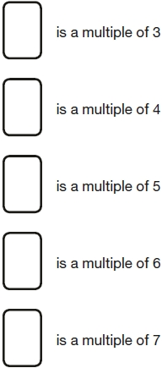
2 marks
Q7.

Amir says,
‘All numbers that end in a 4 are multiples of 4’.
Is he correct?
Circle Yes or No. Yes / No
Explain how you know.

1 mark
Q8.

Here is a number chart.
Circle the smallest number on the chart that is a multiple of both 2 and 7

71 | 72 | 73 | 74 | 75 | 76 | 77 | 78 | 79 | 80
81 | 82 | 83 | 84 | 85 | 86 | 87 | 88 | 89 | 90
91 | 92 | 93 | 94 | 95 | 96 | 97 | 98 | 99 | 100
1 mark
Here is the same number chart.
Circle the largest number that is not a multiple of 2 or 3 or 5

71 | 72 | 73 | 74 | 75 | 76 | 77 | 78 | 79 | 80
81 | 82 | 83 | 84 | 85 | 86 | 87 | 88 | 89 | 90
91 | 92 | 93 | 94 | 95 | 96 | 97 | 98 | 99 | 100
1 mark
Q9.

In the circles, write a multiple that belongs to each set.
One has been done for you.

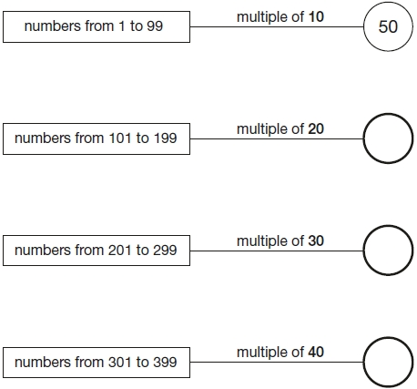
2 marks
Q10.
Circle the prime number.
95 89 87
Explain how you know the other numbers are not prime.
1 mark
Q11.
Circle all the prime factors of 30
2 3 5 6 10
1 mark
Q12.

Here are three digit cards
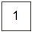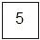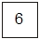
Choose two cards each time to make the following two-digit numbers.
The first one is done for you.

an even number
an prime number
a common factor of 60 and 90
a common multiple of 5 and 13
2 marks

Mark schemes
Q1.
Award TWO marks for numbers written in the correct regions as shown:
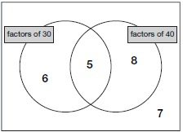
If the answer is incorrect, award ONE mark for any three numbers written in the correct regions.
Do not accept numbers written in more than one region.
Accept alternative indications such as lines drawn from the numbers to the appropriate regions of the diagram.
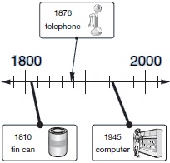
Lines need not touch the time line provided the intended accuracy is clear.
Up to 2
[2]
Q2.
Award TWO marks for only three correct boxes ticked, as shown:

2
3
6
9
12
Award ONE mark for:
• only two correct boxes ticked and no incorrect boxes ticked
OR
• three correct boxes ticked and one incorrect box ticked.
Accept alternative unambiguous positive indications, e.g. Y.
Up to 2 marks
[2]
Q3.

Award TWO marks for any three of the following numbers written in any order:
• 2
• 6
• 10
• 30
If the answer is incorrect, award ONE mark for two numbers correct.
Up to 2m
[2]
Q4.
Three multiples of 3, eg:
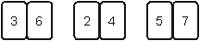
OR
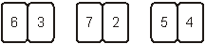
Multiples may be given in any order.
Digits may be in either order, eg 24 OR 42
Do not accept digits used more than once.
Do not accept digits other than those shown.
U1
[1]
Q5.

24 AND 48 only
Numbers may be given in either order.
[1]
Q6.
Award TWO marks for the correct answer as shown:
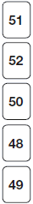
If the answer is incorrect, award ONE mark for 4 true statements
with no number repeated (within those 4), eg:
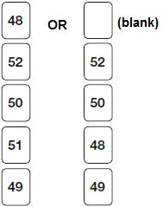
Do not accept numbers other than those given.
(Multiple of 3 can be 48 OR 51)
(Multiple of 4 can be 48 OR 52)
Up to 2
U1
[2]
Q7.
An explanation which gives a counter-example to illustrate that not all numbers
ending in 4 are multiples of 4, eg:
• ‘14 is not a multiple of 4’
• ‘4, 24 and 44 are multiples of 4, but not 14 and 34’
• ‘14 or 34 don’t work’
• ‘54’
OR
an explanation which recognises that only numbers ending in 4 which have
an even number of tens are multiples of 4, eg:
• ‘It has to have an even number of 10s as well, like 20 or 40’
• ‘14, 24, 34, 44, 54, 64 – only half of them are’
• ‘4 doesn’t go into 10 so 14 isn’t’.
No mark is awarded for circling ‘No’ alone.
Do not accept vague or incomplete explanations, eg:
• ‘Some numbers end in a 4 but aren’t multiples of 4’
• ‘16 doesn’t end in 4’
• ‘Not all multiples of 4 end in 4’
• ‘24 is a multiple of 4 but the next one isn’t’
• ‘4, 8, 12, 16, 20, 24 etc’.
If ‘Yes’ is circled but a correct, unambiguous explanation is given, then award the mark.
U1
[1]
Q8.
(a)
71 | 72 | 73 | 74 | 75 | 76 | 77 | 78 | 79 | 80
81 | 82 | 83 |  | 85 | 86 | 87 | 88 | 89 | 90
91 | 92 | 93 | 94 | 95 | 96 | 97 | 98 | 99 | 100
1
(b)
71 | 72 | 73 | 74 | 75 | 76 | 77 | 78 | 79 | 80
81 | 82 | 83 | 84 | 85 | 86 | 87 | 88 | 89 | 90
91 | 92 | 93 | 94 | 95 | 96 |  | 98 | 99 | 100
Do not award the mark if more than one number is circled.
Accept alternative unambiguous indications, eg numbers ticked, crossed or underlined.
1
[2]
Q9.
Award TWO marks for three rows completed correctly as shown:
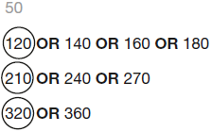
If the answer is incorrect, award ONE mark for two rows correct.
Up to 2
[2]
Q10.
Award ONE mark for a correct explanation of why the 95 AND 87 are NOT prime, e.g.
• 87 is divisible by 3 and/or 29 AND 95 is divisible by 5 and/or 19
• 87 is in the 3 times table AND 95 is in the 5 times table
• 95 is divisible by five because every number in the five times table ends in five or zero. 87 is divisible by three because 9 is in the three times table so is ninety. Ninety minus three is 87
• 8 + 7 = 15 and 15 is divisible by 3 AND 95 is divisible by 5
No mark is awarded for circling ‘89’ alone.
Both non-primes must be explained correctly for the award of the mark.
Do not accept vague or incomplete explanations, e.g.
• The other 2 numbers have more than 2 factors (vague)
• 87 is divisible by 3 (incomplete).
Do not accept explanations which include incorrect mathematics or incorrect information that is relevant to the explanation, e.g.
• 3 × 27 = 87
• 89 has three factors
• no numbers go into 89
[1]
Q11.
Award ONE mark for 2, 3 and 5 circled only.
[1]
Q12.
All three correct
61
15
65
2
or
Any two correct
1
[2]

