 | Phonics/  Spelling | English | Break | Maths fluency | Maths | Lunch | Topic session 1 | Break | Topic session 2
Monday | Phonics play: Phase 5 Cheeky Chimps game | Read ‘Magpie’s Journey Home’.  Use one colour to highlight the nouns. Use another colour to highlight the adjectives. |  | Circle the tens in these numbers  69  143  24 | https://classroom.thenational.academy/lessons/revisiting-the-value-of-coins-comparing-value-74rkcr |  | DT  https://classroom.thenational.academy/lessons/to-explore-a-range-of-sliders-and-levers 69jkgc?activity=video&step=1 |  | DT  https://classroom.thenational.academy/lessons/to-explore-and-evaluate-products-with-moving-parts-70tkjc
Tuesday | https://www.bbc.co.uk/games/embed/small-town-superheroes?exitGameUrl=http%3A%2F%2Fbbc.co.uk%2Fbitesize%2Farticles%2Fzncgvk7 | Read the short passage ‘Dog’s spellings’. There are 10 spellings mistakes. Can you spot them all? Correctly rewrite each misspelt words. If you are struggling to spell them remember you can use a dictionary. |  | Name a 3D shape that has a rectangle as one of its faces | https://classroom.thenational.academy/lessons/coins-and-notes-6wup4t |  | ART  https://classroom.thenational.academy/lessons/exploring-printing-with-found-objects-6wv32r |  | ART  Continue making your patterns with your prints using a variety of techniques (rotating, repeated patterns)  Please send pictures to alders@constablelee.lancs.sch.uk
Wednesday | Phonics play: Practice tricky words Phase 5 | Pick your favourite of the two stories you have heard and then write about why you like it the best on ‘My Favourite Story.’  Say what happens in the story and explain why you like it, giving three reasons why. Use the ideas on ‘Reasons’ to help you get started.  Use your best handwriting and word spacing in your writing. Remember to use capital letters and full stops in all your sentences. |  | Insert a number to make these calculations correct.  34 < ?  25 > ? | https://classroom.thenational.academy/lessons/counting-money-in-a-set-of-coins-65h32d |  | MINDFULNESS  See mindfulness activity on the next page |  | P.E  https://www.youtube.com/c/TheBodyCoachTV/videos  Participate in a Joe Wicks session
Thursday | https://www.bbc.co.uk/bitesize/topics/z8mxrwx/articles/zqghtyc | Read ‘The snake song’ by John Mbiti  Answer these questions  1. How many verses does the poem have?  2. Which verse is the ‘odd one out’ in the poem? Can you explain what makes that verse different to all the others?  3. What things get repeated in each of the verses?  4. Is there any rhyming within a verse?  Write a poem about a deadly creature  Using the writing frame and write a poem about an animal of your own choice based on The Snake Song.  · Use the writing frame if you wish to.  · Then make a ‘very best handwriting’ copy of your poem on the poem paper. You may need more than one sheet.  · Decorate the borders with imagery that goes with your animal |  | 24-12 = ?+?  ?+? = 14-5 | https://classroom.thenational.academy/lessons/revisiting-the-value-of-coins-65jp2r |  | HISTORY  https://classroom.thenational.academy/lessons/what-was-life-like-in-the-17th-century-6dk3ed |  | HISTORY  https://classroom.thenational.academy/lessons/how-did-london-begin-6wu64c
Friday | Phonics play: home Practice Phase 5 sounds | Read the poem ‘The Spangled Pandemonium’ by Palmer Brown.  Explore rhyme patterns in ‘The Spangled Pandemonium’. Use a felt pen or crayon to highlight the rhyming words in each verse  On ‘Rhyming Set’, add as many words as you can to each set and score some points! |  | Continue the pattern | https://classroom.thenational.academy/lessons/change-from-a-pound-6wwkac |  | DRAMA  https://classroom.thenational.academy/lessons/making-it-up-as-we-go-along-6wtk4r |  | DRAMA  https://classroom.thenational.academy/lessons/what-happens-when-bad-things-happen-in-stories-64w34e

Mindfulness activity
Fishy Feet
Place your foot on a piece of paper. Draw around your foot with a pencil or crayon. Use the shape of your foot to design and create a funky fish – use your toes as tail fin!

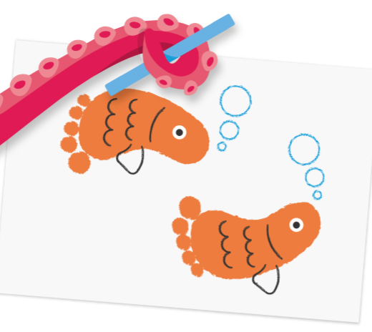

Active Live Survey
Each year, we participate in the Active Lives survey which measures physical activity levels of adults and children in England. Please can you complete the survey, it takes a few minutes and will ask you some simple questions about your physical activities.
As a school we are looking for at least 30 responses from across school but the more we get the better. Here is the link and the school URN number.
https://ipsos.uk/IFZQP
School URN: 119367
Thank you for your support.

Phonics Play
Log onto Phonics play https://www.phonicsplay.co.uk/
Username: jan21
Password: home
Play phase 5 tricky word games

Oxford owl
Please spend time reading with your child. If you are running out of books at home oxford owl has ebooks for your children to read. https://home.oxfordowl.co.uk/reading/free-ebooks/

#21minutechallenge
Rossendale School Sports Partnership have put together a number of resources to help our children and families stay active during this lockdown. To support this, they have launched the 21 minute challenge. The aim is to take part in at least 21 minutes of continuous exercise every day, whether it is going out for a walk, taking part in a home learning task from school, playing out with siblings or completing a Joe Wicks workout. We are encouraging our school and home learners (and their families) to take part and log their daily activities. Please follow the home learning links on our school website for the activity log. It would be amazing to see as many of our families getting out and being active. https://www.thorn.lancs.sch.uk/pe-resources-rossendale-school-sports-partnership-/

National Marine Aquarium
Deep Science
Every Friday during the lockdown, you will be able to tune in to two special shows on our Youtube Channel here: Click here to visit our YouTube channel
FRIDAYS AT 1:00PM – 1:20PM [KS1&2]
The first, ‘Deep Science’ (1:00pm – 1:20pm) will see our Aquarium teachers meet some of our amazing animals as well as stopping in at our Aqua Lab to explore the science behind the animated ocean exploration tv series ‘The Deep’ (CBBC @12pm on weekdays during lockdown). Expect fascinating facts and real time experiments, as well as ideas to follow up with at home (curriculum linked of course!) https://www.youtube.com/user/NMAPlymouth/videos
Key themes for each week are as follows:
15th Jan – Underwater Volcanoes
22nd Jan – Creature Classification
29th Jan – Nautical Navigation
5th Feb – Ocean Mysteries
12th Feb – Megafauna
19th Feb – Life Cycles
26th Feb – Looking after the Ocean

