 | Phonics/  Spelling | English | Break | Maths fluency | Maths | Lunch | Topic session 1 | Break | Topic session 2
Monday | Phonics play phase 6: Magical Matching | Listen to the author, Robert Munsch, read his story The Paper Bag Princess on YouTube at https://www.youtube.com/watch?v=hIPrbsA6Uo&t=168s. And/or watch a version with the illustrations and text https://www.youtube.com/watch?v=P0lNFZtpq7A  What are the names of the three characters in The Paper Bag Princess?  o Pick one, draw them and write their name carefully at the top of Characters. Don’t forget to use an initial capital letter.  o Write correctly punctuated sentences describing what they look like.  o Do the same to say what kind of personality they have.  o Use exciting and interesting adjectives to describe your nouns. Challenge yourself to add adverbs as well if you want. |  | A square has how many corners? | https://classroom.thenational.academy/lessons/identifying-shapes-by-the-number-of-vertices-and-sides-6djp2e |  | DT  https://classroom.thenational.academy/lessons/to-explore-a-range-of-users-and-purposes-cgu3gr |  | DT  https://classroom.thenational.academy/lessons/to-investigate-and-evaluate-cards-that-include-a-variety-of-mechanisms-and-moving-parts-c9hk2d
Tuesday | https://www.bbc.co.uk/bitesize/topics/z8x6cj6/articles/z3dcmsg | Read a monster poem, It’s Behind You! by David Harmer.  • Would you have been able to stop yourself turning round?  • What would you have done to save the poor person in the poem?  Looking at the Poem…  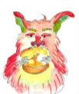  • What is the punctuation mark called at the end of the title?  • Highlight all the exclamation marks in the poem. How many are there?  • Why are they there?  • Highlight all the words in capital letters. Why has the writer done this with these words?  • Read the poem again. This time, use the exclamation marks and capital letters as a guide to where to really stress lines and/or words.  Ask someone to listen to you read. Can they hear how good it sounds? |  | If 28 = 20 + 8, then 31 = ? | https://classroom.thenational.academy/lessons/identifying-right-angles-in-shapes-65jp2r |  | ART  https://classroom.thenational.academy/lessons/making-a-collagraph-print-c4rk6d |  | ART  Continue making your collagraphy prints using a variety of materials to make different prints.  Please send pictures to alders@constablelee.lancs.sch.uk
Wednesday | https://www.bbc.co.uk/bitesize/topics/zrqqtfr/articles/zqbjy4j | Read and enjoy the monster poems There are Gribbles by Paul Cookson and Next Door by David Harmer.  • What other things might the child in Next Door have seen or heard their neighbours doing that would have made the child think they were flies? Crawling on the window, buzzing round a fizzy drink, getting stuck in a spider’s web, flying round a light bulb.  Read through the categories on the Poem Comparison Chart  Put a tick or a cross in each box.  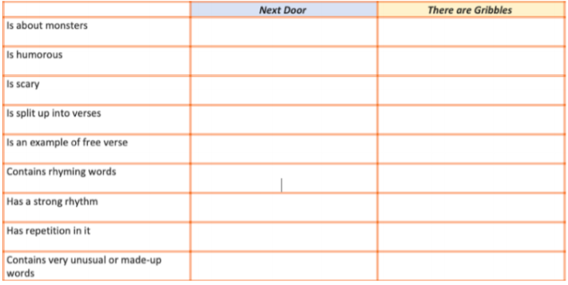 |  | Carry on the sequence  45, 55, 65, ?, ?, ? | https://classroom.thenational.academy/lessons/recognising-lines-of-symmetry-within-2-d-shapes-chh6ct |  | MINDFULNESS  See mindfulness activity on the next page |  | P.E  https://www.youtube.com/c/TheBodyCoachTV/videos  Participate in a Joe Wicks session
Thursday | https://www.bbc.co.uk/bitesize/topics/z8x6cj6/articles/zcm3qhv | Gribbling  ‘Gribbling’ is one of the very unusual words in the poems.  • What do you think ‘gribbling’ might be? Is it a sound the monsters make? Is it a movement? • On A Gribble Gribbling, draw a picture of a Gribble gribbling and write some sentences explaining what you think gribbling is. |  | What number is five less than 21? | https://classroom.thenational.academy/lessons/describing-and-sorting-2d-shapes-cmtpae |  | HISTORY  https://classroom.thenational.academy/lessons/how-was-the-great-fire-of-london-put-out-6rwkjt |  | HISTORY  https://classroom.thenational.academy/lessons/what-was-the-impact-of-the-great-fire-on-london-c9h6cd
Friday | https://www.bbc.co.uk/bitesize/topics/zrqqtfr/articles/z2xdng8 | Re-read There are Gribbles and Next Door and It’s Behind You! Then read a new poem by Paul Cookson, The Football Field Foul Fiend.  • Which is the most fun to say out loud?  • Say why it is the best to read out.  Re-read The Football Field Foul Fiend.  • Introduce the idea of alliteration, using Looking for Alliteration and following the instructions.  Decide which monster poem of the four you have read you like the most .  • On My Best Monster Poem write out the title of the poem.  • Now write a series of correctly punctuated sentences explaining why you thought it was the best. |  | Alice has 20p. Sweets cost 5p each? How many can she buy? | https://classroom.thenational.academy/lessons/naming-and-describing-3d-shapes-c9gkec |  | SCIENCE  https://classroom.thenational.academy/lessons/what-is-the-difference-between-deciduous-and-evergreen-trees-c5j6ar |  | SCIENCE  https://classroom.thenational.academy/lessons/what-are-the-parts-of-trees-and-plants-called-c9h6cr

Mindfulness activity
Jar of Joy
Find an empty jam jar and decorate it. Every day , put a positive word that starts with the first letter of your name into he jar. For example if your name is Jake you could use ‘joyful’, ‘jolly’ or ‘jazzy’.

Science week
British Science Week is a ten-day celebration of science, technology, engineering and maths which will take place between 5-14 March 2021.
You can download British science packs from the British Science Week website: https://www.britishscienceweek.org/plan-your-activities/activity-packs/

The BBC have lots of links to a variety of best science, technology, engineering and maths resources.
https://www.bbc.co.uk/teach/british-science-week/zg9c3j6

Lancashire Adult Learning
Lancashire Adult Learning has developed 2 themed sessions based around Science Week – Super family science for parents/ carers and their children to sign up to, have some fun and hopefully ignite or further develop a passion for Science.
Super Family Science
Tuesday 9th March 2021 – 4:00pm to 5:30pm
Thursday 11th March 2021 – 4:00pm to 5:30pm
ENROL HERE: https://www.lal.ac.uk/course/science-week-super-family-science/BWDT1040/
Phonics Play
Log onto Phonics play https://www.phonicsplay.co.uk/
Username: jan21
Password: home
Play phase 5 tricky word games

Oxford owl
Please spend time reading with your child. If you are running out of books at home oxford owl has ebooks for your children to read. https://home.oxfordowl.co.uk/reading/free-ebooks/

#21minutechallenge
Rossendale School Sports Partnership have put together a number of resources to help our children and families stay active during this lockdown. To support this, they have launched the 21 minute challenge. The aim is to take part in at least 21 minutes of continuous exercise every day, whether it is going out for a walk, taking part in a home learning task from school, playing out with siblings or completing a Joe Wicks workout. We are encouraging our school and home learners (and their families) to take part and log their daily activities. Please follow the home learning links on our school website for the activity log. It would be amazing to see as many of our families getting out and being active. https://www.thorn.lancs.sch.uk/pe-resources-rossendale-school-sports-partnership-/

