Week 2 Challenge
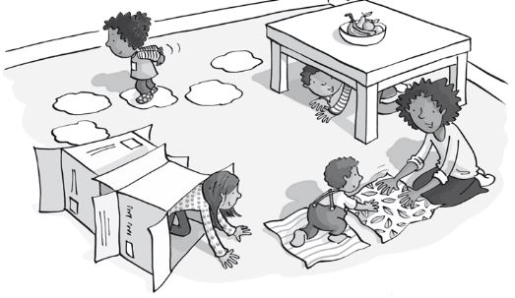
Every week we will set a challenge for pupils to have a go at.
Design an Obstacle Course
- Design an obstacle course in your home or garden. Or chalk draw your course on a pavement or path. Remember to ask an adult for advice on where to set up your obstacle course.
What you might need:
- Pencils
- Paper
- Chalk
- Household items such as tins, bottles, string/rope, toys, chairs, rolled up socks, balls
- Your imagination!
Examples- https://www.youtube.com/watch?v=lCYBkNht_j8
https://www.raisingdragons.com/indoor-obstacle-course-for-kids/

-

Instructions
- Draw out a plan for your obstacle course on paper
- Think of a theme, for example pirates where you have to walk the plank to balance or add sharks to areas where you can’t step.
- You could include hopscotch, running, crawling und thunder or over a row of chairs, crawl under string stretched between two chair legs, jump in and out of a circle 5 time, throw a rolled up sock in a laundry basket to be able to move on, run whilst balancing a rolled up sock on your head. Be creative!
- Now you have designed your course, let’s set it up!
- Once you have created your course and set up, have a go and ask an adult to time you, record your time and see if you can beat it on your next go! Challenge your adults or siblings to complete your course,
- We would love for you to share your photos of your design and videos of you taking part. Ask your adults to send to your teachers or to our Facebook page.
- There will be a prize for the most creative course produced!
- https://www.facebook.com/Rossendalessp/

-

Extended Task ‘Wacky Races’
Activity: A variety of races using different movement skills!
- Take part in 3 different races
- Keep practicing and try to beat your best time
‘Body Relay’
- Set up the course as below using household objects as
the cones

- You can only have 1 body part touching the floor, then 2 body parts, 3 body parts and then 4 body parts
- Your score is the time it takes to complete the course.

‘Obstacle Relay’
- Set up the course as per the diagram using
household objects such as toys for the cones

- Your score is the time it takes to complete the course. To make it harder you can increase the distance for each activity

‘Get Inventive’
- Get inventive and come up with your own relay race. Think of different movements and different activities that you could incorporate into the relay course and see what time you get! For example could you do a silly walk race or a bear crawl race! Or use your obstacle course that you have just set up.

